3D Pomodoro Timer – Roadmap

WHAT IS POMODORO?
The pomodoro technique is a popular time-management method designed to help people stay focused and avoid mental fatigue. It was developed in the late 1980s by Francesco Cirillo, a university student at the time who was struggling to stay productive.
The name comes from the Italian word for “Tomato” (pomodoro).
- How it works:

- Choose a task you want a simple, repetitive cycle.
- Set a timer for 25 minutes (This interval is called one pomodoro)
- Work exclusively on the tsk until the timer rings. If a distraction pops up, write it down and immediately get back to the task.
- Take a short 5-minute break after each pomodoro. Step away from your desk, stretch, or grab water.
- Repeat the cycle. After completing 4 Pomodoro’s, take a long break of 15 to 20 minutes.
- The Pomodoro is Indivisible. If you finish a task early, use the remaining time for "overlearning" or reviewing. If you get interrupted, you must either end the Pomodoro there or postpone the distraction.

- Objective of this technique:

- Combats Procrastination: It’s easier to commit to just 25 minutes of work than an indefinite "afternoon of studying."
- Maintains "Flow": By scheduling breaks before you get tired, you keep your mental energy high throughout the day.
- Reduces Burnout: The mandatory breaks prevent that "fried" feeling after long hours of work.
- Tracks Time: You start to learn exactly how many "Pomodoro’s" a certain task actually takes.

Project Idea
Create a visually engaging Pomodoro timer where a 3D object (apple, orange, tomato) represents the countdown. Users can focus on tasks while tracking time in a fun and interactive way, without unnecessary stats or distractions.

Target Users
- Students studying or preparing for exams
- Office workers / freelancers needing focused sessions
- Anyone using the Pomodoro technique

Core Features (MVP)
- 3D Timer Object
- Rotates to 0 from the described time by the user or by default.
- Timer Controls
- Start / Pause / Reset
- Configurable focus and break durations
- Optional Sound Cue
- Gentle alarm when session ends
- Minimal UI
- Clean, distraction-free layout\
- Report of the usage and no of pomodoro

Tech Stack
- Frontend: HTML + Three.js (for 3D visualization)
- Backend (optional): Python (FastAPI ) if you want session tracking or login later
- Storage (optional): SQLite
- Deployment: Free cloud hosting (GitHub Pages for frontend-only, PythonAnywhere / Render / Railway for backend)

My visualization
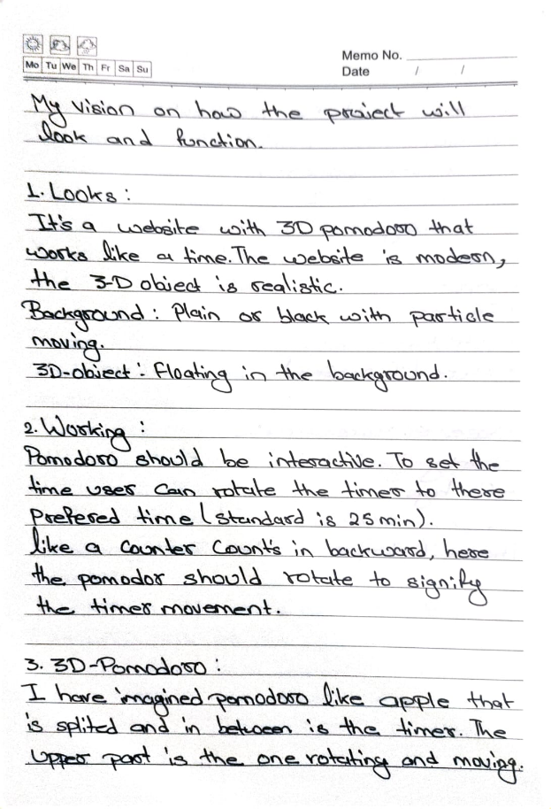
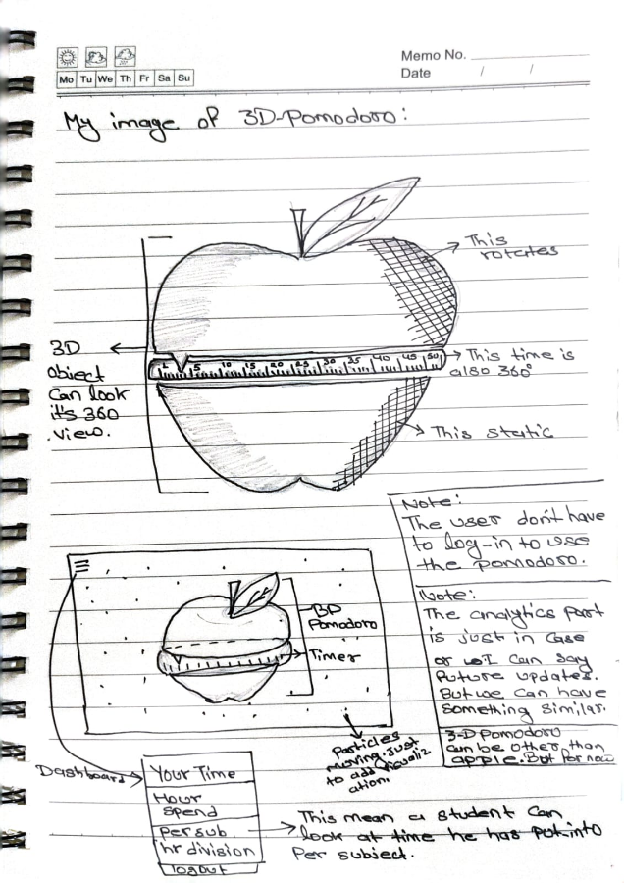
Success Criteria
- Timer visually represents time clearly
- Timer runs accurately (focus and break durations)
- Easy for users to start a session without instructions
- Engaging enough that users prefer it over existing block-style timers

Optional Future Enhancements
- Theme customization (colors / shapes)
- Track streaks and sessions locally or in the cloud
- Mobile-friendly version
- Rewards for no of Pomodoro’s user collect.

